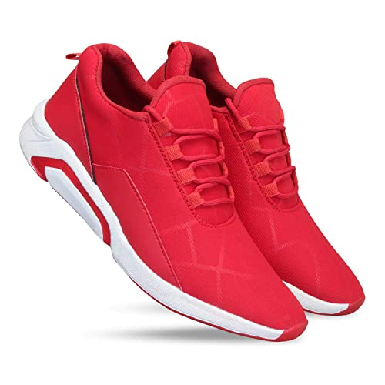

*zhiVago*

*IF THE SHOE FITS, BUY IT!!*

**THE IDEA:** **zhiVago**

**Description:** ‘Zhivago’ we realize that style and prosperity begin with the correct shoes.

**Written By**: G. NIKHIL SAI

**Contact Information:** ✉️nikhil.g@tuitionworld.co.in 📞 7680048836

**Last Updated:** 18-Jan-2023

**Content:**

Overview:

Summary

Purpose

The Market

Features of Adjustable Shoes & Finding the Best Fit

Advantages & Disadvantages:

Investments

Unique selling point

Conclusion

**Overview:**

**Summary:**

#### At **zhiVago**, we believe style shouldn't demand a huge investment of time or money. Style should be comfortable, accessible and easy to achieve. That's why our footwear feels as good as it looks, effortlessly taking you from the **boardroom to the restaurant**, **to the park with your family**. We strive to ensure your shopping experience is easy on your wallet, and your schedule, by delivering fashion and value to everyone in your household.

**Purpose:**

#### . A flexible fit can be important for your foot health and comfort, and for people who need extra options, adjustable shoes are a must. Adjustable shoes are exactly what they sound like; shoes that can be adjusted to your preferences, and may come with various options including adjustable shoelaces and adjustable straps. Establishment a repeat customer base by ensuring that the quality of the shoes produced meets the standards expected by consumers.

**The Market:**

Indian footwear industry produced around 2.2 billion shoes in 2015, where 90% was consumed internally while the balance was exported to different parts of the world. India was a part of $126 billion export market in which its share was approximately 2% which is relatively low in comparison with China (13.8 billion shoes, 40% export share). Within the industry the unorganised sector plays a crucial role in acting as a competitor to the existing brands. Zhivago will be one of the organisations in the coming years.

**Features of Adjustable Shoes & Finding the Best Fit:**

Explore the process of selecting and fitting the ideal adjustable shoe for your feet and activity preferences. Adjustable shoes come with various features and can serve different purposes, whether you’re looking for pain relief or others. Luckily, **zhiVago** Footwear has designed shoes that can mold to your feet over time. This is especially important when you need comfort that other shoes can’t provide.

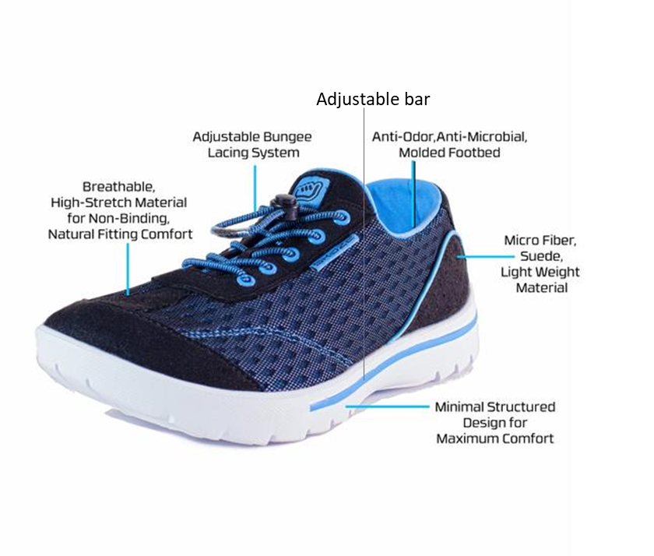

**Advantages & Disadvantages:**

|  |  |
| --- | --- |
| **Advantages** | **Disadvantages** |
| Easy flexible | Time -consuming process |
| Hard gripping | Non-removable |
| recyclable | Fixed-extensions |
| Extra space fitting | Carbic-fiber |

#### **Investments:**

#### An asset acquired with the goal of generating income or appreciation overtime.

**NOTE: Investment is calculated on basic ideology depends on future executions**

**Money is denominated in Lakhs (eg: 2.5Lakhs).**

### Unique selling point:

#### A unique selling point (USP), also called a *unique selling proposition*, is a marketing statement that differentiates a product or [brand](https://www.techtarget.com/whatis/definition/brand) from its competitors. A USP might boast the lowest cost, the highest quality, the most experience, the first in its product class or another trait that sets the offering apart from the competition. A unique selling point can be thought of as "what you have that competitors don't."



zhiVago Shoes' unique selling point is that **for every pair of shoes a customer purchases, the company donates a pair to a child in need**.

#### **Conclusion:**

#### To conclude, zhiVago Company is known as the most respected and popular shoe brand because of its quality, from the early partition days. It is an internationally renowned brand and satisfies the needs of every country where it is present with respect to its specific cultural requirements, weather conditions and customer-specific considerations. One of the zhiVago’s goals is to provide shoes for everyone, every occasion and suitable for every career. zhiVago provides tremendous value and convenience with an incredible variety of styles. Customers have seen Bata's shoes as highly innovative in fashion trends by continuously offering new types of men's shoes, women's shoes, children's shoes, school shoes. The word Bata is synonymous with efficiency and trends.